**PIZZA SALES SQL QUERIES**

**A. KPI’s:**

**1.Total Revenue:**

SELECT SUM(total_price) AS Total_Revenue FROM pizza_sales;

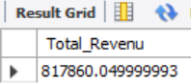

**2.Avg Order Value:**

SELECT (SUM(total_price) / COUNT(DISTINCT order_id)) AS Avg_order_Value FROM pizza_sales

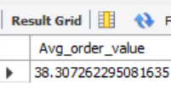

**3.Total Pizza Sold:**

SELECT SUM(quantity) AS Total_pizza_sold FROM pizza_sales

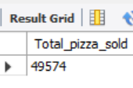

**4.Total orders:**

SELECT COUNT(DISTINCT order_id) AS total_order FROM pizza_sales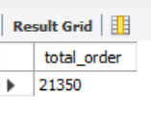

**5.Avg pizza per order:**

SELECT CAST(CAST(SUM(quantity) AS DECIMAL(10,2)) /

CAST(COUNT(DISTINCT order_id) AS DECIMAL(10,2)) AS DECIMAL(10,2))

AS Avg_pizzas_per_order

FROM pizza_sales

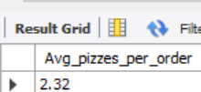

**B. Daily trend from total order:**

SELECT DATENAME(DW, order_date) AS order_day, COUNT(DISTINCT order_id) AS total_orders

FROM pizza_sales

GROUP BY DATENAME(DW, order_date)

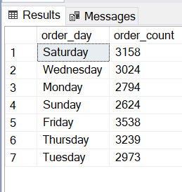

**C. Monthly Trend From Total order:**

select DATENAME(MONTH , order_date) as order_day , count(distinct order_id) as order_count from pizza_sales

group by DATENAME(MONTH , order_date);

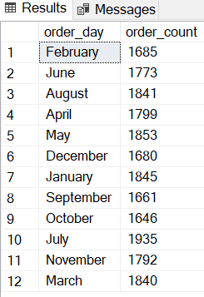

**D. percentage of sales by pizza category:**

SELECT pizza_category, CAST(SUM(total_price) AS DECIMAL(10,2)) as total_revenue,

CAST(SUM(total_price) * 100 / (SELECT SUM(total_price) from pizza_sales) AS DECIMAL(10,2)) AS PCT

FROM pizza_sales

GROUP BY pizza_category **;**

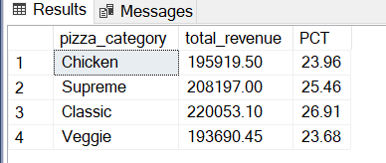

**E. percentage of sales by pizza size :**

SELECT pizza_size, CAST(SUM(total_price) AS DECIMAL(10,2)) as total_revenue,

CAST(SUM(total_price) * 100 / (SELECT SUM(total_price) from pizza_sales) AS DECIMAL(10,2)) AS PCT

FROM pizza_sales

GROUP BY pizza_size

ORDER BY pizza_size

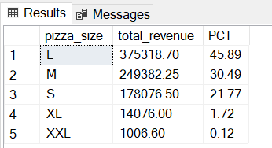

**F. Top 5 Pizza By Revenue:**

SELECT Top 5 pizza_name, SUM(total_price) AS Total_Revenue

FROM pizza_sales

GROUP BY pizza_name

ORDER BY Total_Revenue DESC

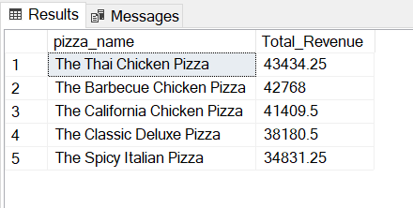

**G. Top 5 Pizza by Orders:**

SELECT Top 5 pizza_name, COUNT(DISTINCT order_id) AS Total_Orders

FROM pizza_sales

GROUP BY pizza_name

ORDER BY Total_Orders DESC

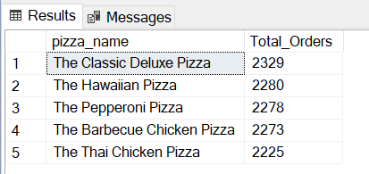

**H. Top 5 Pizza by Quantity:**

SELECT Top 5 pizza_name, SUM(quantity) AS Total_Pizza_Sold

FROM pizza_sales

GROUP BY pizza_name

ORDER BY Total_Pizza_Sold DESC

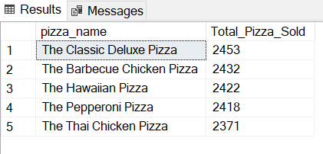

**I. Bottom 5 Pizza by Revenue**

SELECT Top 5 pizza_name, SUM(total_price) AS Total_Revenue

FROM pizza_sales

GROUP BY pizza_name

ORDER BY Total_Revenue ASC

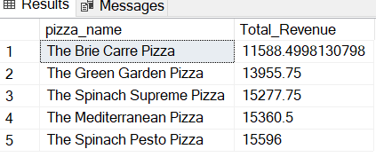

**J. Bottom 5 Pizzas by Quantity**

SELECT TOP 5 pizza_name, SUM(quantity) AS Total_Pizza_Sold

FROM pizza_sales

GROUP BY pizza_name

ORDER BY Total_Pizza_Sold ASC

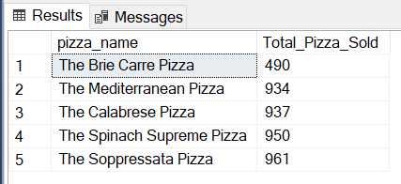

**L. Bottom 5 Pizzas by Total Orders**

SELECT Top 5 pizza_name, COUNT(DISTINCT order_id) AS Total_Orders

FROM pizza_sales

GROUP BY pizza_name

ORDER BY Total_Orders ASC

